**BAIYEWU AFOLAKE SIMBIAT**

**LAB 5 TASK 2**

**STEP 4:** CORRELATION BETWEEN THE CHANGE AND THE CALM VARIABLE

cor_change_calm <- cor(looscan$change, looscan$Calm)  
  
cor_change_calm

0.06206369

**STEP 5:** SCATTERPLOT

library(ggplot2)

sp <- ggplot(looscan, mapping = aes(x = Calm, y = change, color = Age)) +   
 geom_point(size = 2,shape = 23) + geom_smooth(method ='loess', se = FALSE)  
  
sp

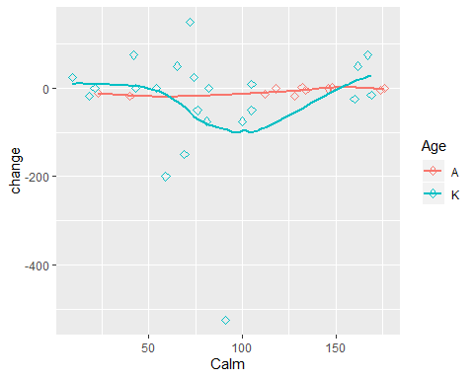

**STEP 7:** THE FIRST MODEL WITH THE SET OF RULES

library(RWeka)  
  
ripper_model <- JRip(Gender~., data = looscan)  
  
ripper_model

## JRIP rules:  
## ===========  
##   
## (Active >= 4) => Gender=M (15.0/6.0)  
## => Gender=F (19.0/6.0)

## Number of Rules : 2

**STEP 8:** SUMMARY OF THE MODEL

summary(ripper_model)

##   
## === Summary ===  
##   
## Correctly Classified Instances 22 64.7059 %  
## Incorrectly Classified Instances 12 35.2941 %  
## Kappa statistic 0.2842  
## Mean absolute error 0.4533  
## Root mean squared error 0.4761  
## Relative absolute error 91.8508 %  
## Root relative squared error 95.8741 %  
## Total Number of Instances 34   
##   
## === Confusion Matrix ===  
##   
## a b <-- classified as  
## 13 6 | a = F  
## 6 9 | b = M

**STEP 11:** THE SECOND MODEL WITH THE SET OF THE RULES

ripper_model2 <- JRip(change~., data = looscan)  
  
ripper_model2

## JRIP rules:  
## ===========  
##   
## (Calm <= 54) and (Gender = M) => change=noChange (3.0/0.0)  
## (prelt >= 150) => change=Increase (6.0/1.0)  
## (postlt <= 8.9) => change=Increase (2.0/0.0)  
## => change=Decrease (23.0/4.0)  
##   
## Number of Rules : 4

**STEP 12:** SUMMARY OF THE MODEL

summary(ripper_model2)

##   
## === Summary ===  
##   
## Correctly Classified Instances 29 85.2941 %  
## Incorrectly Classified Instances 5 14.7059 %  
## Kappa statistic 0.7185  
## Mean absolute error 0.1674  
## Root mean squared error 0.2893  
## Relative absolute error 44.6103 %  
## Root relative squared error 67.2963 %  
## Total Number of Instances 34   
##   
## === Confusion Matrix ===  
##   
## a b c <-- classified as  
## 19 1 0 | a = Decrease  
## 3 7 0 | b = Increase  
## 1 0 3 | c = noChange